Chapter 19, Problem 7.

Calculate the impedance-parameter equivalent of the circuit in Fig. 19.71.

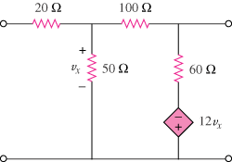

Figure 19.71
For Prob. 19.7.

